Formative Assessment Name: ___________________________
BIOLOGY: Human Circulatory System Time: 15 minutes

Q1. A haematologist was studying a blood smear. What they viewed under the microscope is shown below.
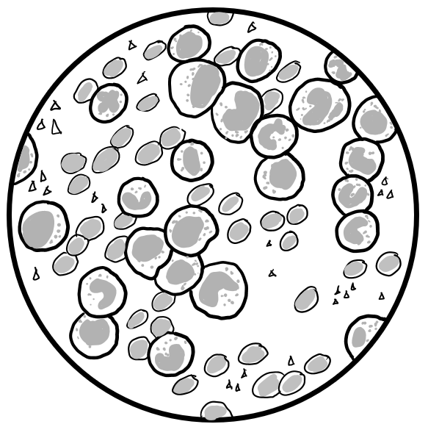
- Label the components of blood on the blood smear image above. (4 marks)
- Compare the structure of white blood cells and red blood cells. (4 marks)
c) The haematologist did not think this blood smear came from a healthy sample. Propose why he might think this by describing evidence shown in the diagram and referring to your learning of blood. (3 marks)

Q2. A student was labelling a diagram of a heart. Their diagram is shown below.
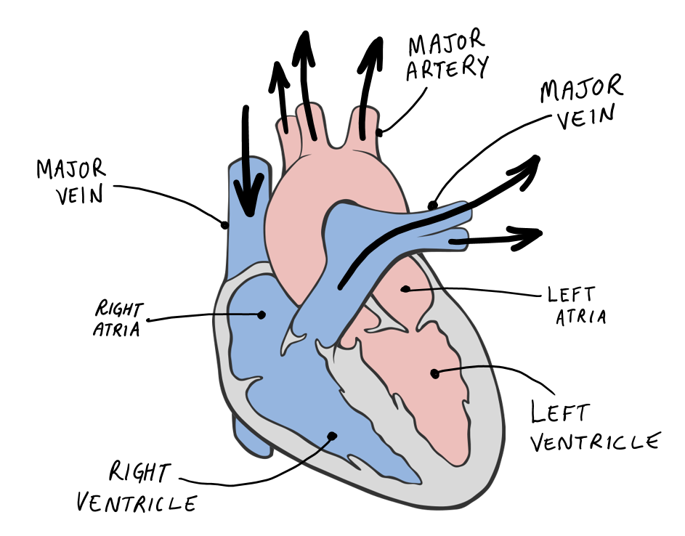
a) The student made an error when labelling their diagram. Circle the error and explain why it is incorrect. (3 marks)

b) Valves can be found in the heart and veins. Describe the role of valves in the circulatory system and add a label for a valve to the diagram above. (3 marks)
PERSONAL LEARNING REFLECTION
One thing I have learnt from doing this activity is… | SCORE:  ______ / 17  _______ %

