Formative Assessment Name: ___________________________
BIOLOGY: Comparing Digestive Systems Time: 10 minutes

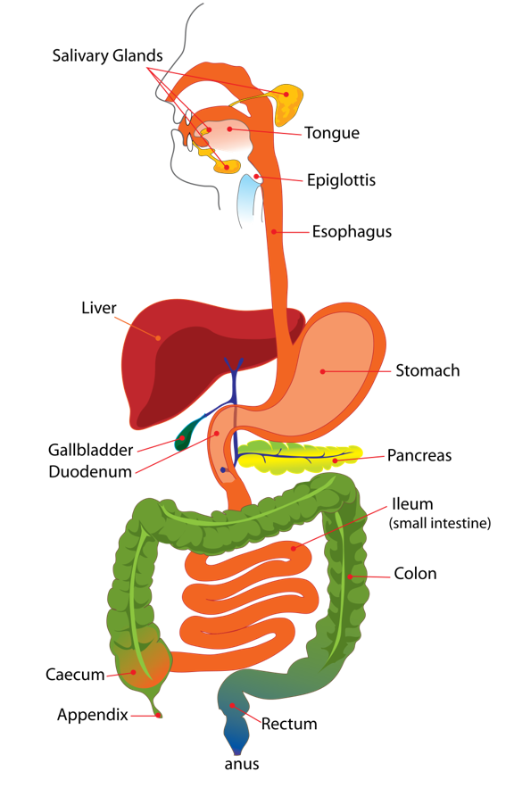
The diagram shows the human digestive system.

1. What are systems composed of? (1 marks)
_________________________________________________

2. Herbivores (i.e. koalas) have quite long digestive systems compared to the short digestive systems of carnivores (i.e. vultures). Explain the cause of this difference. (4 marks)

3. Other than digestive tract length, describe one (1) piece of evidence that humans eat meat and one (1) piece of evidence that humans eat plants. (4 marks)

4. Some herbivores (such as rabbits and koalas), eat their faeces. Use your understanding of the herbivorous digestive system to propose one (1) reason these animals may do this. (2 marks)

PERSONAL LEARNING REFLECTION
One thing I have learnt from doing this activity is… | SCORE:  ______ / 11  _______ %

