Observing Blood
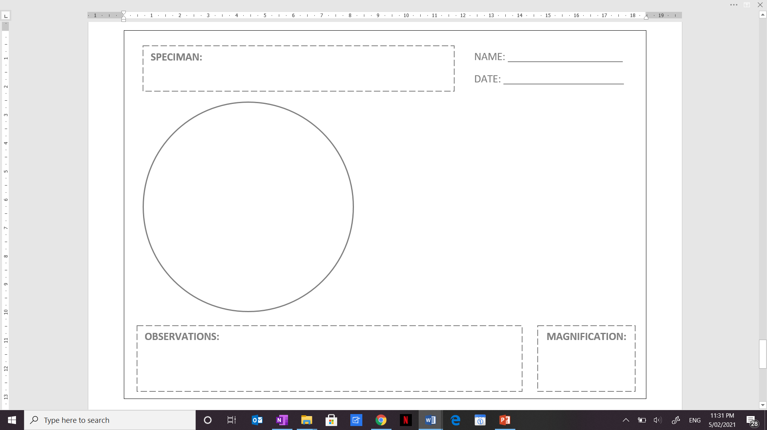
Examining Pre-Made Blood Slides
Use a light microscope to observe pre-made
slides of blood. Create a scientific diagram of
a blood smear that you observe.
Biological Drawing Checklist
Use a sharp pencil (no pen).
Draw a large, clear, and centred image using up the space available.
Include labels that have ruled, straight horizontal lines.
Draw simple, clear lines (no shading, smudging, or feathering).
Include a descriptive title.
Include the total magnification.

Analyzing Irregular Blood Smears
Examine the blood images provided on the Science with Dobrich website. Compare the regular blood smear with the irregular blood smears. Record the differences observed in the smears and make inferences about the irregular blood.
 | Describe the differences you observe | Use your observations to make inferences about the irregular blood smear, i.e. what is happening or how functioning might be effected.
Image 1
Image 2
Image 3
Image 4
Image 5

