Formative Assessment Name: ___________________________
BIOLOGY: Cells & their Parts Time: 10 minutes

Q1) Figure 1 shows two different cells.
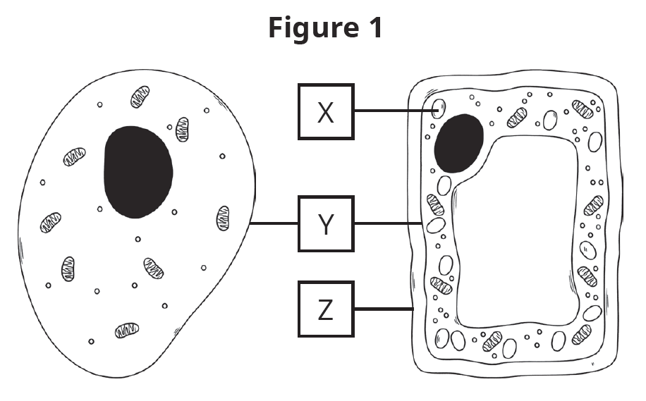
a) Name the parts labelled X, Y and Z. [3 marks]
X: ________________________________
Y: ________________________________
Z: ________________________________

b) Determine which cell is a plant cell (left or right). Provide two pieces of evidence to support your claim. [3 marks]

Q2) Figure 2 shows a diagram of a basic cell.
Figure 2
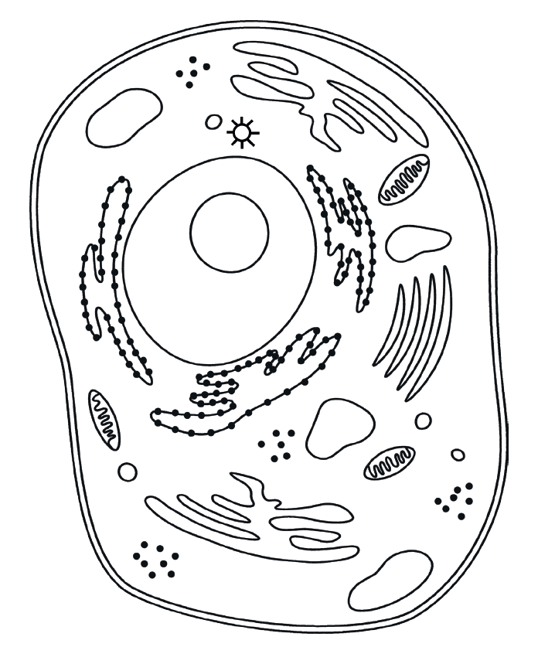
a) Identify the Golgi apparatus by colouring it in on the diagram above. [1 mark]

b) Describe the structure of cytoplasm in the cell. [2 marks]

c) Muscle cells tend to have more mitochondria than other cells. Propose why muscle cells have more mitochondria by describing the function of this cell organelle. [2 marks]

PERSONAL LEARNING REFLECTION
One thing I have learnt from doing this activity is… | SCORE:  ______ / 11  _______ %

