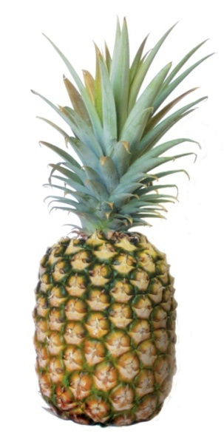**Observing Enzyme Action** Name: _____________________  
 **Many common substances contain enzymes. For example, fresh pineapple, contact lens protein remover, meat tenderiser and some washing powders contain enzymes that breakdown protein found in dirt.**

**Aim:** To observe how enzymes breakdown food.

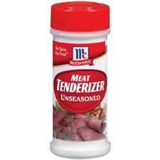

**Equipment:**

* 3 petri dishes of jelly
* 3 pieces of fresh pineapple
* 3 pieces of canned pineapple
* Sticker labels

**Method:**

1. Collect the equipment.
2. Label each petri dish – control, fresh pineapple, and canned pineapple.
3. On the dish labelled fresh pineapple, place three pieces of fresh pineapple.
4. On the dish labelled canned pineapple, place three pieces of canned pineapple.
5. The other dish labelled control should be left as is – plain jelly.
6. Leave the jelly overnight and then observe to see what affect the fresh pineapple and canned pineapple has on the jelly.

**Background Research:**

**Pineapple** contains a chemical called bromelain, which contains two enzymes capable of digesting proteins, which are called proteases. During the canning process pineapple gets heated and the bromelain breaks apart making it inactive.

**Jell-O** and other gelatins [get their structure](http://chemistry.about.com/od/foodcookingchemistry/a/how-jell-o-works.htm) from links formed between chains of [collagen](http://chemistry.about.com/od/polymers/a/Collagen.htm), which is a protein.

**Hypothesis:** *Write a hypothesis for this investigation…*

_________________________________________________________________________________

__________________________________________________________________________________________________________________________________________________________________

**Results:**

|  |  |  |
| --- | --- | --- |
| **FOOD CONTAINING PROTEIN** | **ENZYME ADDED TO JELLY** | **OBSERVATIONS** |
| Jelly | Fresh pineapple |  |
| Jelly | Canned pineapple |  |
| Jelly | None |  |

**Analysis:**

|  |  |  |
| --- | --- | --- |
| **Digested protein**  **(yes/no)** | **Fresh pineapple** | **Canned pineapple** |
|  |  |

**Questions:**

1. What is a control?

___________________________________________________________________________

______________________________________________________________________________________________________________________________________________________

1. Why was it essential to have a control for each experiment? ____________________________________________________________________________________________________________________________________________________________________________________________________________________________________________________________________________________________________________
2. Jelly packets often contain recipes for jellied fruit. However, they always say not to use fresh pineapple. What is the reason for this? (Use your results to support your answer).

____________________________________________________________________________________________________________________________________________________________________________________________________________________________________________________________________________________________________________

1. Tinned pineapple can be put into jelly quite easily and has no effect on the jelly. Why doesn’t it affect the jelly in the same way as the fresh pineapple? (Use your results to support your answer).

____________________________________________________________________________________________________________________________________________________________________________________________________________________________________________________________________________________________________________

1. Why is it important to have enzymes that digest protein in your stomach and small intestines?

_______________________________________________________________________________________________________________________________________________________________________________________________________________________________________________________________________________________________________________________________________________________________________________________