Name: _________________________________
Creating Wet Mount Slides
A wet mount microscope slide is a slide preparation technique used to observe living organisms or specimens in a liquid medium under a microscope. It involves placing a specimen in a drop of liquid on a slide, covering it with a cover slip, and sealing the edges to prevent drying.
TASK 1 – Creating a Wet Mount Slide to View Onion Cells

STEP 1: Cut onion into chunks. Use tweezers or a toothpick to place a small, thin sheet of onion on the centre of a microscope slide.
STEP 2: Add a drop of water or iodine onto the onion sheet using a pipette or dropper.
STEP 3: Carefully lower a cover slip onto the onion sheet, avoiding air bubbles.
STEP 4: Gently press down on the cover slip to spread the onion cells and remove excess fluid.
STEP 5: Wipe away any excess water around the edges using a tissue.
STEP 6: Place the slide on the microscope stage and observe the onion cells under low and high magnifications.
STEP 7: Draw a labelled scientific diagram of your observations.
X
TITLE: ___________________________
___________________________
Biological Drawing Checklist
Use a sharp pencil (no pen).
Draw a large, clear, and centred image using up the space available.
Include labels that have ruled, straight horizontal lines.
Draw simple, clear lines (no shading, smudging, or feathering).
Include a descriptive title.
Include the total magnification.

TASK 2 – Creating a Wet Mount Slide to View Pond Water
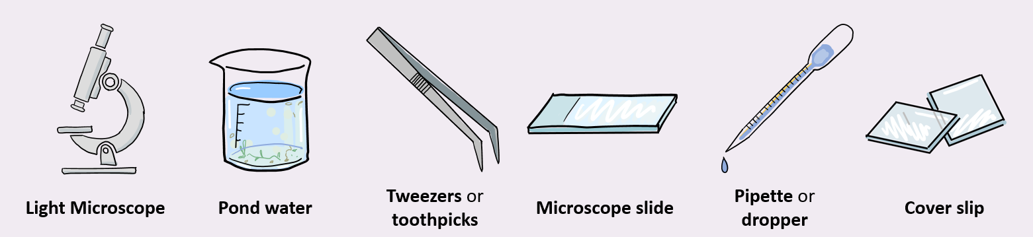
STEP 1: Collect a small sample of pond water using a dropper or pipette.
STEP 2: Place a drop of pond water in the centre of a clean microscope slide. Do NOT add dye as this may harm living organisms in the sample.
STEP 3: Gently lower a cover slip onto the water drop, avoiding trapping air bubbles.
STEP 4: Allow the cover slip to settle and spread the pond water.
STEP 5: Remove excess water from the edges using a tissue.
STEP 6: Place the slide on the microscope stage and observe the microscopic life present in the pond water under different magnifications.
Pond Water i-Spy
1. Predict what types of microorganisms you think will be most abundant in your pond water sample?
2. Observe the pond water sample. Which organisms did you find in your pond water sample?
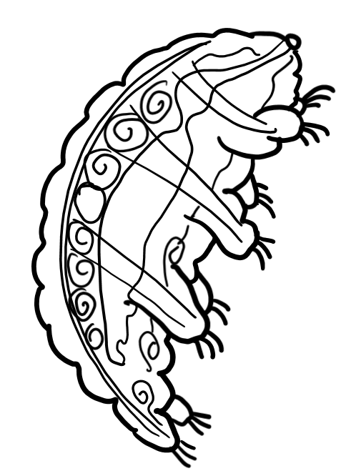 |  |  | 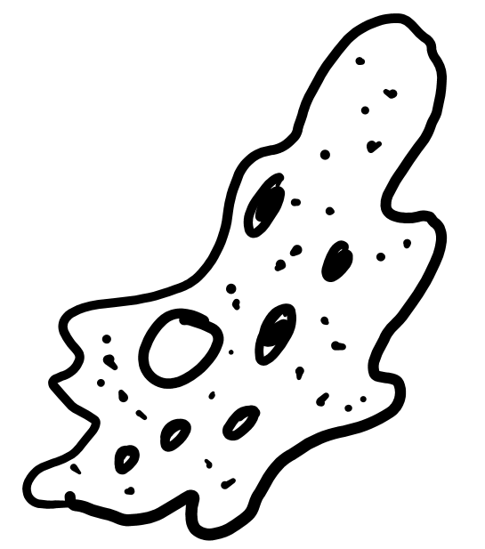 |  |  | 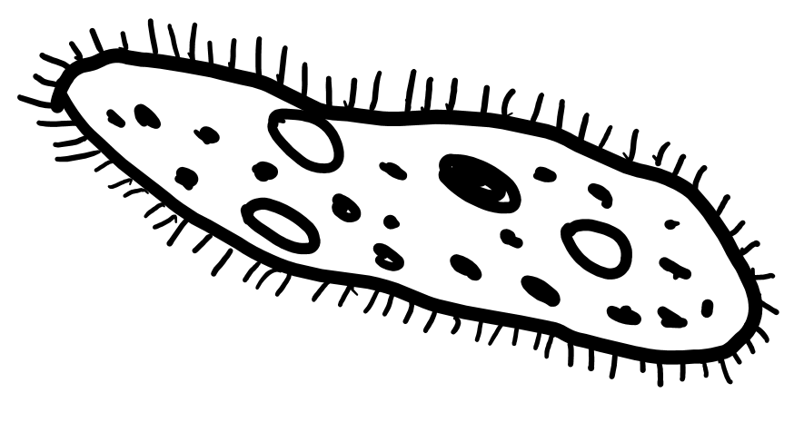 |  |  | 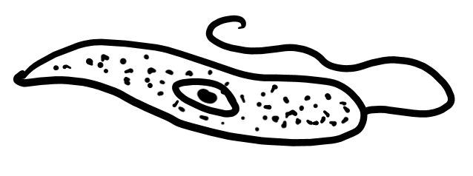 |  | 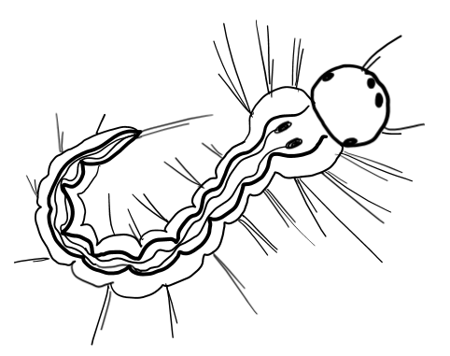
 | Tardigrade  (Water Bear) |  |  |  | Amoeba |  |  | Paramecium |  | Euglena |  |  | Mosquito Larvae
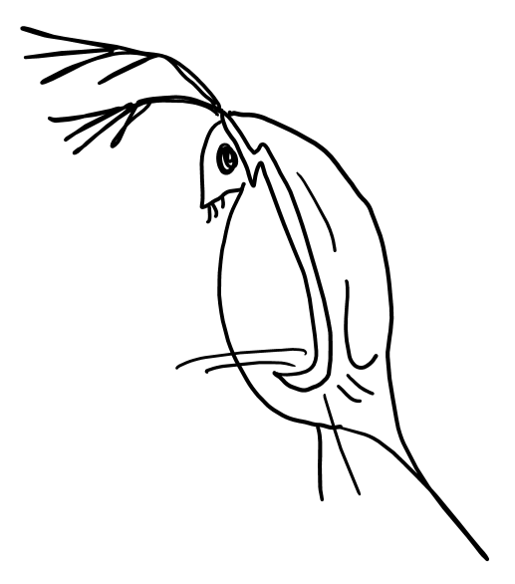 |  |  | 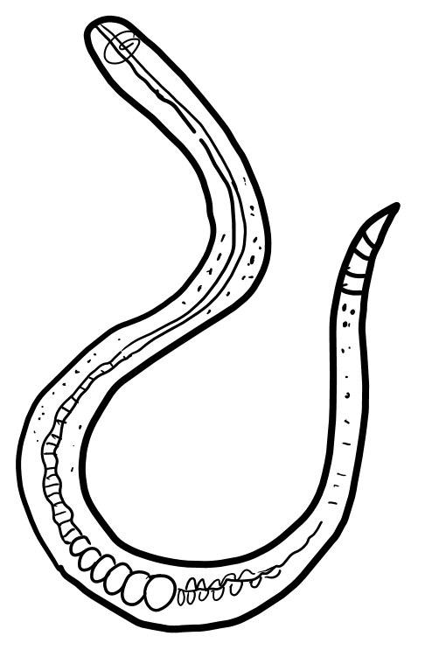 |  |  |  |  |  |  |  | 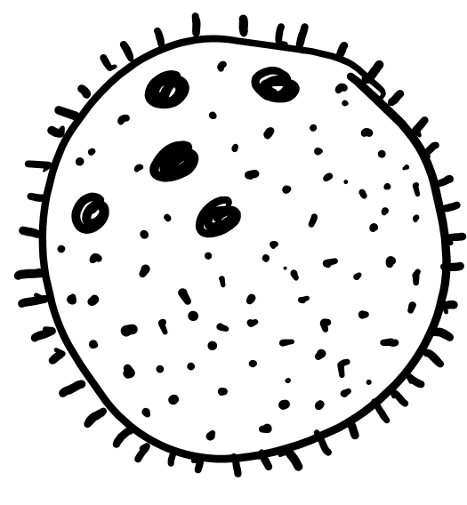
 |  | Daphnia  (Water Flea) |  | Nematode |  |  | Spirogyra |  |  | Diatoms |  | Volvox

3. What else did you observes under the microscope? Draw a diagram showing what you observed.
Biological Drawing Checklist
Use a sharp pencil (no pen).
Draw a large, clear, and centred image using up the space available.
Include labels that have ruled, straight horizontal lines.
Draw simple, clear lines (no shading, smudging, or feathering).
Include a descriptive title.
Include the total magnification.
X
TITLE: ___________________________
___________________________

4. Describe how the microorganisms you observed moved or interacted with their environment?

5. Proposed how the presence of microorganisms might indicate the health of the pond ecosystem?

6. Predict how environmental factors, such as water quality or temperature, might impact the types of microorganisms present?

7. Consider human activities that could affect the pond ecosystem, and how might this impact the microorganisms?

8. Why do you think it's important to study microorganisms in pond water?

TASK 3 - Research and Improve
It is now time to draw on resources to critically review and enhance your previous responses.

- Use the resources available (i.e. the internet, textbook, learning material) to investigate information relating to the questions above.

- Adjust your responses so they are more scientifically accurate.

TASK 4 - Share and Improve
It is now time to discuss your observations, share ideas, and think critically about the connections between microorganisms and the broader environment.

- Move around the room and compare your responses to the responses of your peers.
- Use your discussions with peers to improve and enhance your responses.

TASK 5 - Reflect
Describe how engaging in research and discussion with peers helped to enhance your understanding of this topic.

