Name: _________________________________
Heart Dissection

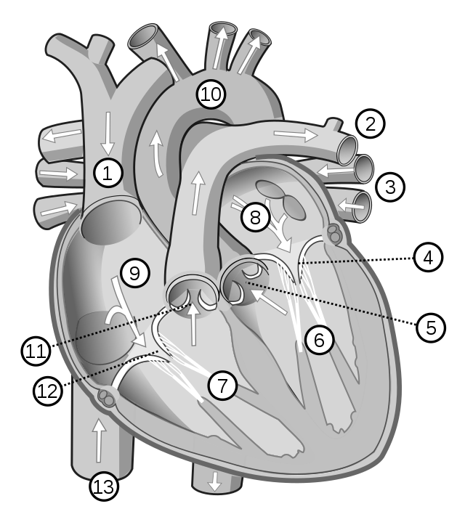
1) Heart Anatomy: Recall the names of the following structures of the heart.

1
2
3
4
5
6
7
8
9
10
11
12
13

2) Real Heart Anatomy: Examine the heart organ. Compare the diagram (above) to a real heart. Describe the similarities and the differences between the diagram of a heart and the real organ.

Similarities | Differences

3) Comparing Atria & Ventricles: Compare the thickness of the atrial walls with the ventricular walls. What implications does this have for their functions?

4) Comparing Left & Right Ventricles: How does the left ventricle differ from the right ventricle in terms of structure and function?

5) Design inspired by nature: If you were to design an artificial water pump, what features would you incorporate based on the principles learned from the heart dissection? Explain your choices.

