Name: _____________________________

**Journey of a Cheese Sandwich**

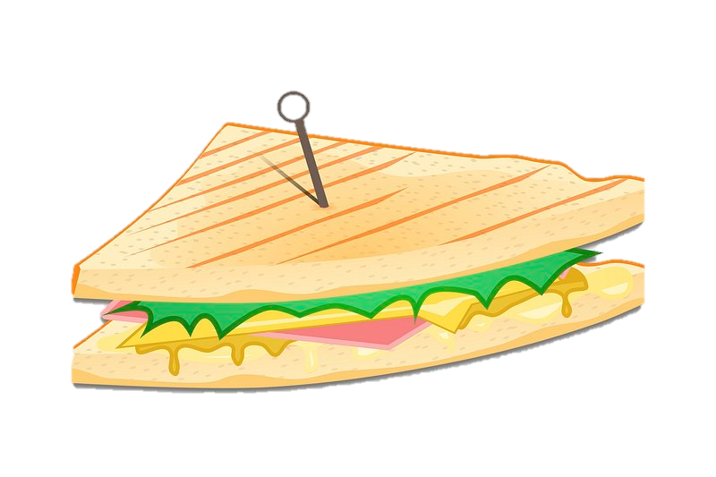

**YOUR TASK:** Explain the journey of a cheese sandwich through your digestive tract. Be creative in expressing your knowledge. Select from one of the following options:

|  |  |
| --- | --- |
| **Select a way to present your learning:** | |
|  | Poster / Infographic |
|  | Children’s book |
|  | Poem, song, or rap |
|  | Blog / magazine article |
|  | Video |
|  | Podcast |
|  | Model / diorama |
|  | Illustration / Ed. colouring page |
|  | Graphic organiser |
|  | Other: ________________________ |

**TOP TIPS:**

* Describe what happens in each organ of the digestive system.
* Consider which food groups are in a cheese sandwich.
* Use scientific ideas of cells and particles if you can.

**LEARNING LADDER:**

|  |  |
| --- | --- |
| **Beginner Level** | |
|  | Identified the majority of digestive system organs. |
|  | Provided explanations for the food processing within each organ. |
|  | Listed the food categories in a cheese sandwich. |
|  | Offered a rationale for the body's dietary requirements. |

|  |  |
| --- | --- |
| **Intermediate Level** | |
|  | Described all digestive system organs sequentially. |
|  | Demonstrated familiarity with the structure and function of digestive organs. |
|  | Offered explanations for food processing in each organ. |
|  | Articulated the significance of each food group for the body. |
|  | Provided a simple description of enzyme involvement in digestion. |
|  | Elaborated on the digestion and absorption of food, drawing on prior knowledge of particles. |

|  |  |
| --- | --- |
| **Advanced Level** | |
|  | Thoroughly detailed all digestive system organs, establishing connections between structure and function at the system, organ, and cellular levels. |
|  | Provided an in-depth explanation of the food processing in each organ. |
|  | Articulated the reasons behind the body's need for each food group. |
|  | Elaborated on the role of enzymes in the digestive process. |
|  | Explained the comprehensive journey of food from digestion and absorption to transportation to cells, leveraging prior understanding of particles. |
|  | Applied prior knowledge of energy to explain how cells utilize food. |