**Formative Assessment**  Name: ___________________________  
BIOLOGY: The Digestive System Time: 15 minutes

**Question 1 (1 mark)**

The gastrointestinal tract includes all the following, except;

**A.** oesophagus

**B.** stomach

**C.** small intestine

**D.** liver

**Question 2 (1 mark)**

Gastric juices in the stomach:

**A.** kill bacteria

**B.** work together to digest food

**C.** include hydrochloric acid

**D.** all of the above

**Question 3 (1 mark)**

The stomach:

**A.** only does chemical digestion

**B.** only does mechanical digestion

**C.** does both chemical and mechanical digestion

**D.** starts the chemical digestion of starchy foods.

**Question 4**

Villi are found in the digestive system. The diagram below shows 2 villi.

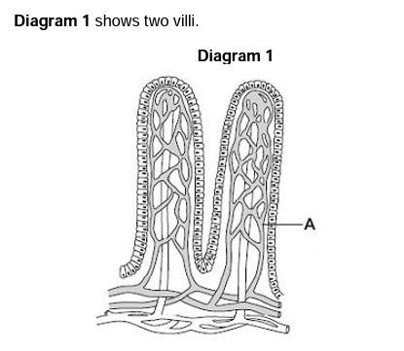

**a)** Name the structure labelled as A: ________________________________________ **(1 mark)**

**b)** Draw a circle around the correct answer to complete the sentence. (**1 mark)**

The villi absorb the products of digestion by: ***dialysis diffusion osmosis***

**c)** Refer to the diagram of the digestive system below to answer the questions.

**i)** In which part of the digestive system, X, Y or Z are most villi found?   
  
 ________ (**1 mark)**

**ii)** There are about 2000 villi in each cm2 of this part of the digestive system. Why is it important to have lots of villi? **(2 marks)**

|  |
| --- |
|  |
|  |
|  |
|  |
|  |

**iii)** Name the parts labelled in the diagram above and describe their role in the digestion of food. **(6 marks)**

|  |  |  |
| --- | --- | --- |
| **Diagram label** | **Name** | **Function** |
| X |  |  |
| Y |  |  |
| Z |  |  |

**PERSONAL LEARNING REFLECTION**

|  |  |
| --- | --- |
| One thing I have learnt from doing this activity is… | **SCORE:**  ______ / 14  _______ % |