Formative Assessment Name: ANSWER KEY
BIOLOGY: Human Circulatory System Time: 15 minutes

Q1. A haematologist was studying a blood smear. What they viewed under the microscope is shown below.
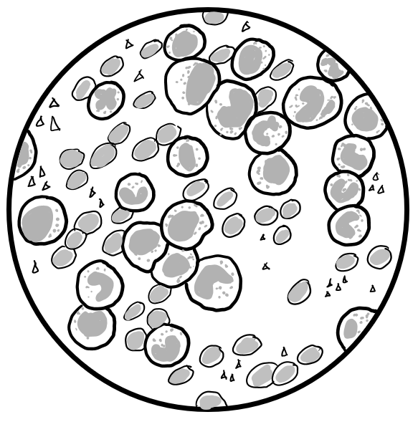
- Label the components of blood on the blood smear image above. (4 marks)
- Compare the structure of white blood cells and red blood cells. (4 marks)
White blood cells are larger (1), than red blood cells (1)
White blood cells contain organelles such as a nucleus (1), whereas red blood cells
lack a nucleus and other organelles (1).
c) The haematologist did not think this blood smear came from a healthy sample. Propose why he might think this by describing evidence shown in the diagram and referring to your learning of blood. (3 marks)
White blood cells make up less than 1% of bloods composition (1).
This blood smear has more white blood cells than expected in a healthy sample (1).
The high levels of white blood cells in this smear suggest this person is sick / has an
Infection / has a disease such as cancer (1).

Q2. A student was labelling a diagram of a heart. Their diagram is shown below.
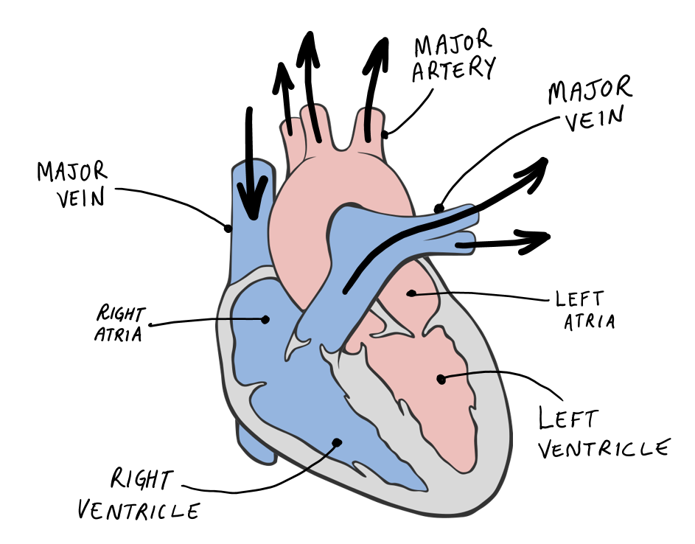
a) The student made an error when labelling their diagram. Circle the error and explain why it is incorrect. (3 marks)
Student has identified the error in the diagram – see above (1)
Veins carry blood to the heart [OR] arteries carry blood away from the heart (1)
The major vessel in the diagram above is carrying blood away from the heart, therefore
it should be labelled as an artery, not a vein (1)

b) Valves can be found in the heart and veins. Describe the role of valves in the circulatory system and add a label for a valve to the diagram above. (3 marks)
Valves ensure the one-directional flow of blood in the circulatory system [OR]
Valves prevent blood from moving backward (1)
This maintains the efficiency / effectiveness of blood circulation (1)
Student has labelled one valve on the diagram above – see example (1)
PERSONAL LEARNING REFLECTION
One thing I have learnt from doing this activity is… | SCORE:  ______ / 17  _______ %

