Formative Assessment Name: ___________________________
BIOLOGY: Microscopes Time: 15 minutes

Q1. Name the parts labelled A to G on the diagram using terms from the box below. (7 marks)
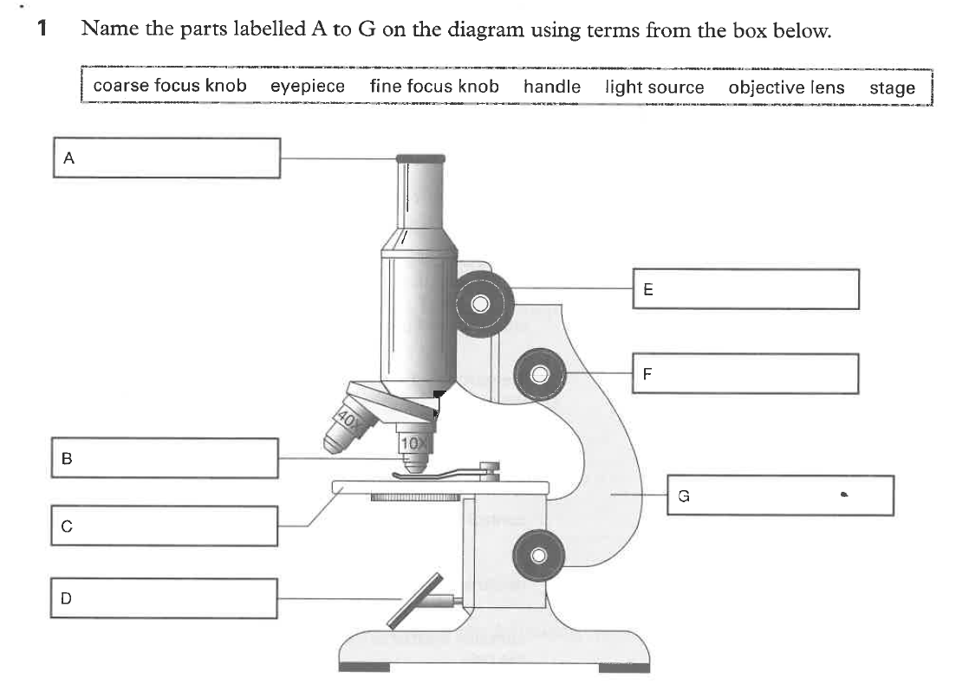

Q2. Complete the missing information in the table below. (4 marks)
 | Term | Definition
a) |  | Unit used to measure microscopic objects.
b) | Ocular lens
c) |  | Part of the microscope on which the specimen is placed.
d) | Coarse focus knob

3 The following diagrams show the field of view for three different magnifications of the same microscope. Work out the diameter of the field of view for each of the magnifications to the nearest whole millimetre (mm) and micrometre (um). (3 marks)
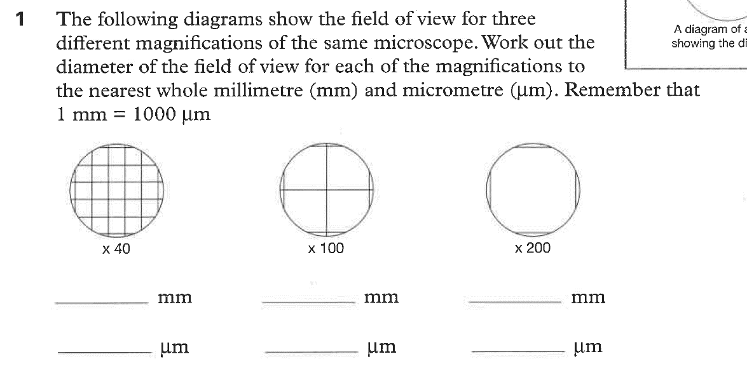
4 Describe the relationship between Field of View (FOV) and magnification. (1 mark)

5 A student was viewing an ‘e’ slide under the microscope. They addressed the slide slightly up and to the left. The ‘e’ remained in the FOV but its position changed. Draw the image the student would see after adjusting the slide. (2 marks)
Initial view | View after moving the slide up and left
e

6 Paramecium swim so rapidly they can be difficult to observe because they move out of the field of view. Propose a way to slow them down so they are easier to examine. (1 mark)

PERSONAL LEARNING REFLECTION
One thing I have learnt from doing this activity is… | SCORE:  ______ / 14  _______ %

