Student Investigation: Name: ______________________
Comparing Circulatory Systems
Until now, you've focused on understanding the human circulatory system; however, it's important to note that circulatory systems across animal’s exhibit diversity. While the fundamental function of these systems remains consistent across different organisms, variations exist in their structure and components.
YOUR TASK:
- You will select, and then research, the circulatory system of an animal from one of the following categories: insects, birds, amphibians, or fish.
- You will present your research in a form of your choosing – see below.
- On presentation day, you will swap-and-share your findings with two of your peers in triad-group presentations.
- You will provide and receive peer constructive feedback during the sharing process.

Select from the following options:
Select a topic to investigate: |  |  | Select a way to present your learning:
 | Insect |  |  | Poster / Infographic
 | Bird |  |  | PowerPoint Presentation
 | Amphibian |  |  | Graphic organiser
 | Fish |  |  | Blog / magazine article
 | Other: ___________________ |  |  | Short video
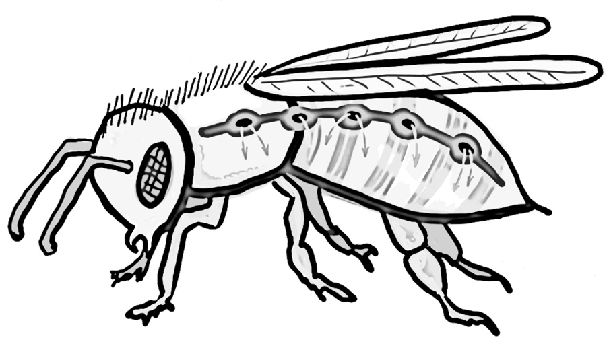 |  |  |  | Podcast
 |  |  |  | Model / diorama
 |  |  |  | Illustration
 |  |  |  | Educational colouring-in page
 |  |  |  | Other: ________________________

Brief overview of what you plan to do:
I will investigate the topic of __________________________________________________ .
I will present my learning by __________________________________________________ .
Background research:
Key word: | Notes:
Diagrams:

