Formative Assessment Name: ___________________________
BIOLOGY: Using Microscopes Time: 10 minutes

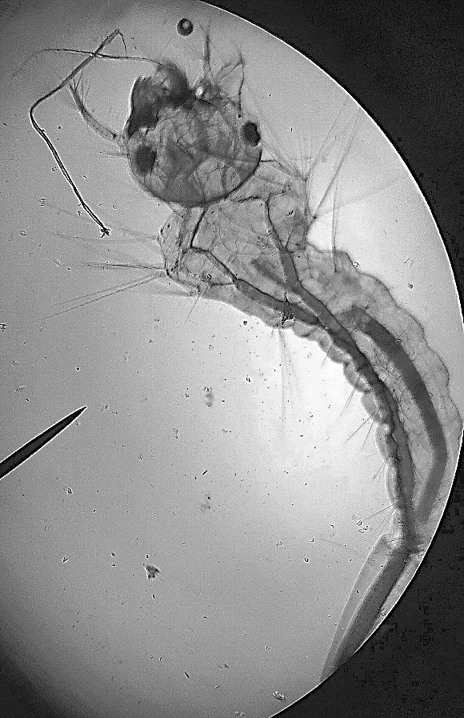
100x
A biologist is researching mosquito larvae and needs to observe them using a light microscope.
Q1. Use the image shown (above) to create a biological drawing of the mosquito larvae. (4 marks)

Q2. Explain how the biologist would use a microscope to observe mosquito larvae. (6 marks)

PERSONAL LEARNING REFLECTION
One thing I have learnt from doing this activity is… | SCORE:  ______ / 10  _______ %

