Formative Assessment Name: Answer Key
BIOLOGY: Comparing Digestive Systems Time: 10 minutes

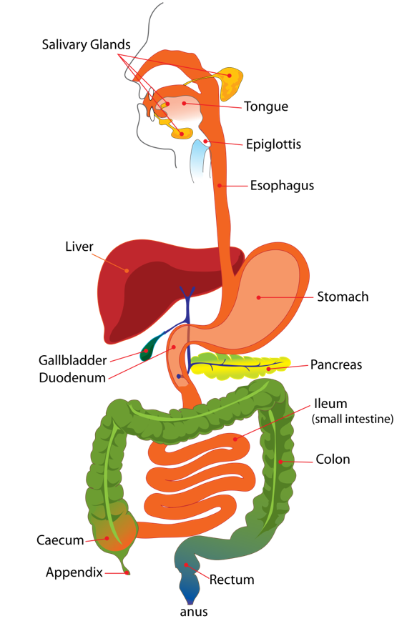
The diagram shows the human digestive system.
1. What are systems composed of? (1 marks)
Multiple organs working together

2. Herbivores (i.e. koalas) have quite long digestive systems compared to the short digestive systems of carnivores (i.e. vultures). Explain the cause of this difference. (4 marks)

This difference in digestive tract length is primarily related to the types of food they consume, and the challenges associated with breaking down those foods.

(1) - Herbivores primarily consume plant material, which is often tough, fibrous, and difficult to digest.
(1) - A longer digestive tract provides sufficient time for digestion to occur.

(1) - In contrast, carnivores consume animal tissues, which are generally easier to digest compared to plant materials.

(1) - Animal tissues contain proteins and fats that can be broken down more efficiently in a shorter digestive system.

3. Other than digestive tract length, describe one (1) piece of evidence that humans eat meat and one (1) piece of evidence that humans eat plants. (4 marks)
Any one pair from each list below:
Evidence for eats meat | Evidence for eats plants
Teeth have pointy canines (1) for tearing through meat (1) | Teeth also have flat molars (1) for grinding up plant matter (1)
The cecum is relatively small (1) because it is not need to digest large amounts of fibrous plant matter (1) | Produce salivary amylase (1) to break down carbohydrates found in plant matter (1).

4. Some herbivores (such as rabbits and koalas), eat their faeces. Use your understanding of the herbivorous digestive system to propose one (1) reason these animals may do this. (2 marks)
Answers will vary – allow variation in student responses.

Some example responses include:
- To re-digest and extract additional nutrients from partially digested material.
- Reintroduce essential gut microbes that may have been excreted in the initial faecal material. This process aids in maintaining a healthy balance of microorganisms in the digestive tract, optimizing the efficiency of plant material digestion.

- Some essential nutrients, such as B vitamins, are synthesized by bacteria in the hindgut of herbivores. Re-eating faeces allows the animals to recover these nutrients, ensuring that they are not lost in the first pass through the digestive system.

PERSONAL LEARNING REFLECTION
One thing I have learnt from doing this activity is… | SCORE:  ______ / 11  _______ %

