Formative Assessment Name: Answer Key
BIOLOGY: Using Microscopes Time: 10 minutes

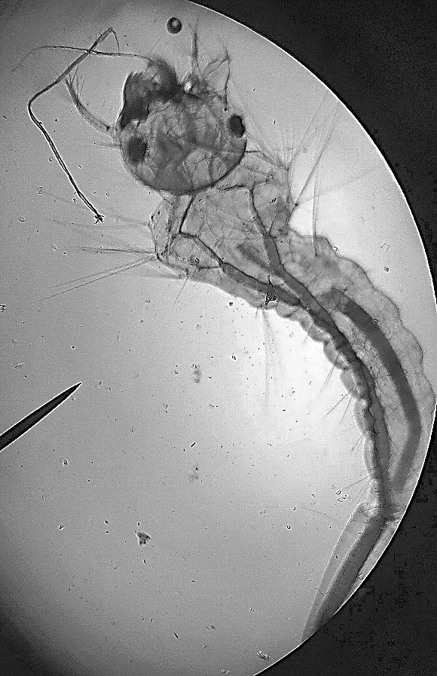
100x
A biologist is researching mosquito larvae and needs to observe them using a light microscope.
Q1. Use the image shown (above) to create a biological drawing of the mosquito larvae. (4 marks)

Marking Guide | Marks
Neat, clean lines created using a sharp pencil. | 1
Simple line drawing (no shading, smudging, or feathering) | 1
Labels are included with neat ruled lines. | 1
Title and magnification are included with the illustration. | 1

Q2. Explain how the biologist would use a microscope to observe mosquito larvae. (6 marks)
Marking Guide | Marks
There is a clear and detailed description of the steps, including the correct names for each part of the microscope. | 5-6
Most of the steps are described. Some parts of the microscope may not be named. | 3-4
There are simple statements that give some steps of the method. | 1-2
No relevant content. | 0

Example response:
- Prepare wet mount by placing mosquito larvae in water on a microscope slide.
- Gently cover with a cover slip to flatten larvae.
- Set up the microscope and secure the slide on the microscope stage.
- Use the coarse focus knob (low magnification) to locate larvae.
- Turn the nosepiece to switch to higher magnification.
- Enhance visibility and focus by adjusting the lighting and turning the fine focus knob (high magnification).
- Observe the larvae and record observations.

PERSONAL LEARNING REFLECTION
One thing I have learnt from doing this activity is… | SCORE:  ______ / 10  _______ %

