**Cell Cake Class Party**

**YOUR NAME: ____________________________ DUE DATE: _____________________________**

**YOUR TASK:** 3D models are a fun and easy way to learn about plant and animal cells. You are required to construct a model plant or animal cell. Remember to label the parts of your cell.

Machine generated alternative text:
STEP 1: Plant Cells vs. Animal Cells
Plant and Animal Cells Have Different Shapes

Decide whether you will create a plant or animal cell. Plant cells and animal cells are shaped differently and contain different organelles. Visit [cellsalive.com](https://www.cellsalive.com/). This site offers awesome animations of both plant and animal cells with descriptions of each organelle.

Machine generated alternative text:
STEP 2: Edible vs. Non-Edible Models
Do you plan to eat your cell model?
Next, you should decide whether you want to make an edible cell model or a
non-edible cell model. Edible cell models can be eaten (yum!) and are
often made with cake, candy, Rice Krispie Treats or Jell-C). Non-edible cell models cannot
be eaten and are often made with craft supplies Like styrofoam, pipe cleaners and clay.

Next, you should decide whether you want to make an edible cell model or a non-edible cell model. Edible cell models can be eaten (yum!) and are often made with cake, candy, rice crispy treats or Jelly. Non-edible models cannot be eaten and are often made with craft supplies like Styrofoam, pipe cleaners or clay.

Machine generated alternative text:
What Type of Cell Model Are YOU Making?
Plant or Animal Cell? Edible or Non-Edible?
Which 3D cell model are you building?
C Edible animal cell model (yum!)
C Non-edible animal cell model
C Edible plant cell model (delicious!)
C Non-edible plant cell model

Machine generated alternative text:
What Type of Cell Model Are YOU Making?
Plant or Animal Cell? Edible or Non-Edible?
Which 3D cell model are you building?
C Edible animal cell model (yum!)
C Non-edible animal cell model
C Edible plant cell model (delicious!)
C Non-edible plant cell model

Machine generated alternative text:
STEP : Parts of the Cell
Plant and animal cells have different parts!
Now you need to make a list of all the parts, or organelles, you wifi need to include in your 312
cell model. Organelles are the “mini organs” found inside every plant and animal cell. Each
organelle has a different function and physical appearance, and together they work to keep the
cell alive. Here’s a breakdown of the organelles found in each type of cell:
ANIMAL CELL:
1. Cell Membrane
2. Cytoplasm
3. Nucleus
4. Golgi Apparatus
5. Endoplasmic Reticulum
6. Ribosomes
7. Mitochondria
8. Vacuoles
9. Lysosomes

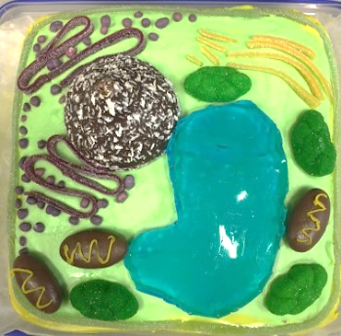Now you need to make a list of all the parts, or organelles, you will need to include in your 3D cell model. Organelles are the “mini organs’ found inside every plant and animal cell. Each organelle has a different function and physical appearance, and together they work to keep the cell alive. Here’s a breakdown of the organelles found in each types of cell:  
  
Machine generated alternative text:
STEP : Parts of the Cell
Plant and animal cells have different parts!
Now you need to make a list of all the parts, or organelles, you wifi need to include in your 312
cell model. Organelles are the “mini organs” found inside every plant and animal cell. Each
organelle has a different function and physical appearance, and together they work to keep the
cell alive. Here’s a breakdown of the organelles found in each type of cell:
ANIMAL CELL:
1. Cell Membrane
2. Cytoplasm
3. Nucleus
4. Golgi Apparatus
5. Endoplasmic Reticulum
6. Ribosomes
7. Mitochondria
8. Vacuoles
9. Lysosomes

Machine generated alternative text:
PLANT CELL:
1. Cell WaIl
2. Cell Membrane
3. Cytoplasm
4. Nucleus
5. Golgi Apparatus
6. Endoplasmic Reticulum
7. Ribosomes
8. Mitochondria
g. Central Vacuole
lo. Chloroplasts

You will need to bring your models to class on ________________________________________________.   
  
Prizes will be awarded to the best models produced. Any edible models can then be eaten.